AIPM Latest News
Excellent News: An AIPM supported church, Javea International Baptist Church in Spain, has called a permanent Pastor. AIPM has been privileged, along with ministers from the UK, to provide interim ministry as the church readied themselves to call a pastor. We have also been pleased to have three couples serve in UK churches in recent times. This is our ministry: to provide interim ministers who can enable a church to be ready to call a permanent pastor.
This encouraging ministry also faces its challenges. In 2025 we became aware that the latest regulations of UK Visas and Immigration (UKVI) will not allow AIPM to continue to send Interim Ministers of Religion (Interim Ministers) to the UK to serve as volunteers. We have been working with a UK lawyer who specializes in visas and immigration so that we are on the right side of UK law to share the gospel of grace. We are excited at the possibility of continuing helping churches in Britain and wherever God sends us – Spain was not on our radar screen.
Our new approach, in lieu of volunteering, has the UK church providing a stipend. The stipend will allow the Interim Minister to pay certain ministry expenses at close to the same cost as our previous arrangement. The cost to the Interim Pastors will be similar to the earlier arrangement.
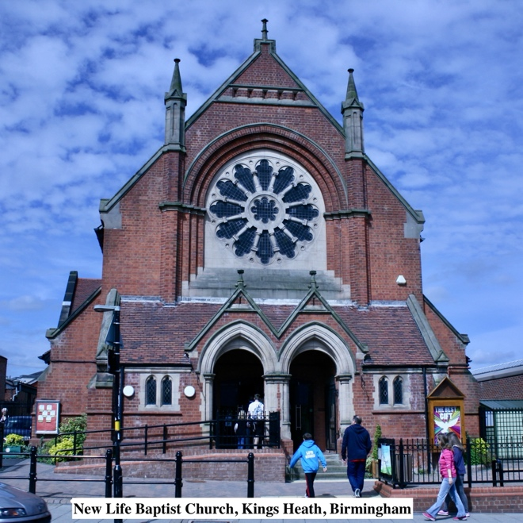
In the days ahead, we hope to present information on this website about additional UK churches that believe AIPM can be of help and who are able to meet the new regulations – more complex than in the past but entirely doable.
We hope people that God wishes to call to serve UK churches will watch our website for opportunities. If God calls and they answer His call, they will be richly blessed as they serve. And the opportunity to become lifelong friends with British believers in Jesus and to welcome worshippers as New Life in Brimingham are doing in the photo will bring tremendous blessings.

Every blessing!
Chuck McComb

