Where American Interim Pastors Have Served
Places of Service 2000 – 2026
(#) Number of Interim Ministers

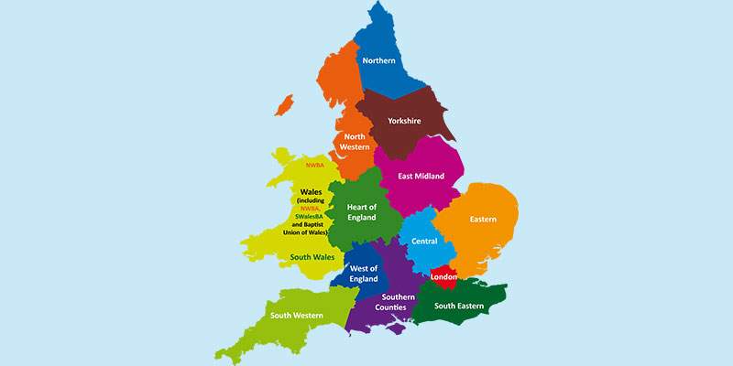
London Area
St. Andrew’s Community (1)
Yorkshire
Milnsbridge (3) Mirfield (3)
Doncaster (1) Morley Community(1)

Warwickshire
Henley-in-Arden (7)

Birmingham
New Life Kings Heath (1 now) Spring Lane Hockley Heath (1) now)Heath
Spring Lane
Derby
Littleover (3)
Gloucestershire
Stow-on-the-Wold (4)
Oxfordshire
Ducklington (2)
Cumbria
Bootle Evangelical
Church (6)
Spain
Javea International Baptist Church (3)
Skegness
St. Paul’s Baptist (3)
Teesside Area
Cambridge Road (2)
Thornaby (7) West View (1)
Northamptonshire
Ringstead (1)
Revised August 2026
Mid-County Durham
Bishop Auckland (1) Crook (1)
Hamsterley (5) Wolsingham (4)
Tyneside Area
Westoe Road (2)

